Working Sheet – What is this?

STM Picture

Measurements & Calculations:
- Measure the length of the picture: ______ cm

- Calculate scale:
2nm correspond to _____cm
1nm correspond to _____cm

- Measure the distance between 6-9 atoms (if possible), in 3 different directions:
_______cm; ______cm; ______cm

- Calculate atomic distance on print out:
(Distance (cm)) / (number of atoms -1);
for example: the distance between 8 atoms was measured to be 7cm:
7cm / (8-1) = 1 cm
Direction 1: _____cm / (__-1) = ______ cm
Direction 2: _____cm / (__-1) = ______ cm
Direction 3: _____cm / (__-1) = ______ cm
Mean value: (_____cm + _____cm + _____cm) / 3 = _____cm

- Calculate atomic distance in real (in nm; include the scale from nb. 2)
From nb. 4: atomic distance on print out: _______cm
From nb. 2: scale: 1nm correspond to _______cm
Atomic distance / scale = scaled atomic distance = _____ nm

Answer: The atomic distance seems to be ______nm

- Read the following definitions. Search for more information in google, if necessary.
- Atomic distance: is the distance between the two closest neighbours in a crystal
- Lattice constant: refers to the physical dimension of unit cells in a crystal lattice
- Unit cell: repeating pattern in a crystal structure
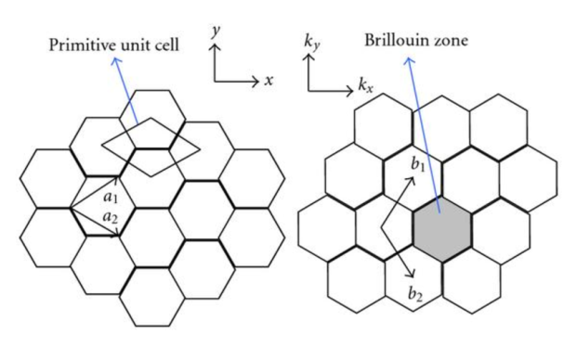
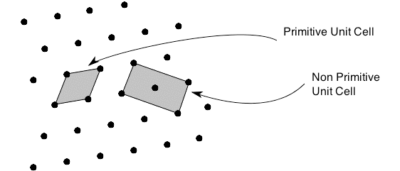

- Collect further information, like atomic structure, atomic distance, lattice constant etc. of the following 4 substrates:
  - Molybdeneum Disulfite

  - Sicilcon

  - Graphite

  - Graphene

- Decide using your calculations and the further information from above, which of the 4 substrates from nb. 7 is shown in the STM picture.

